Hisabdaar Business Management System
Accounting | Sales | Inventory | CRM | Reporting | Business Operations

Project Overview
Hisabdaar is a complete business management system built to manage sales, customers, products, purchases, expenses, inventory, accounting, payments, and reports from one platform.
The system provides a centralized dashboard and module based structure for managing daily business operations and financial activities.
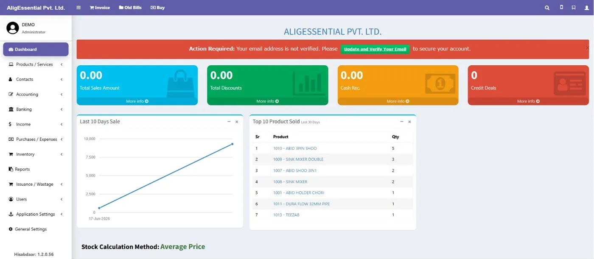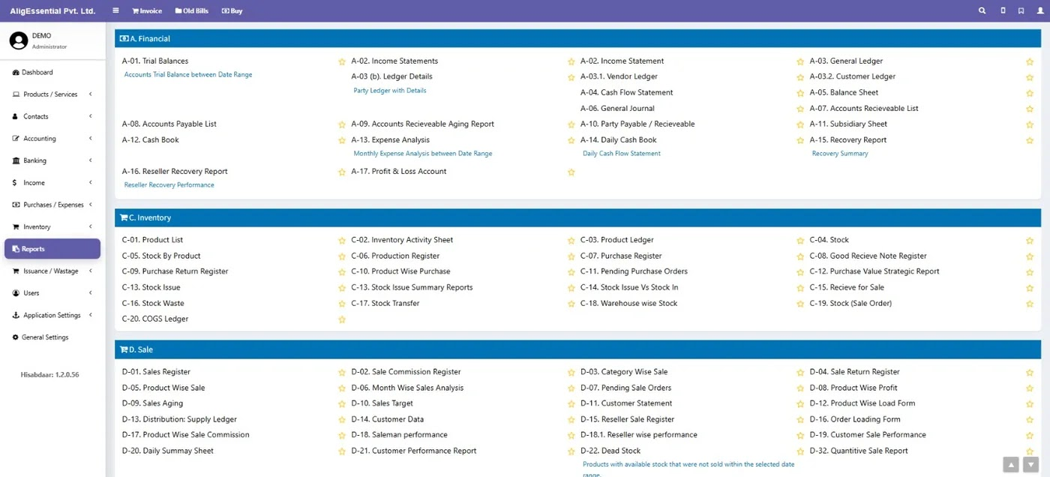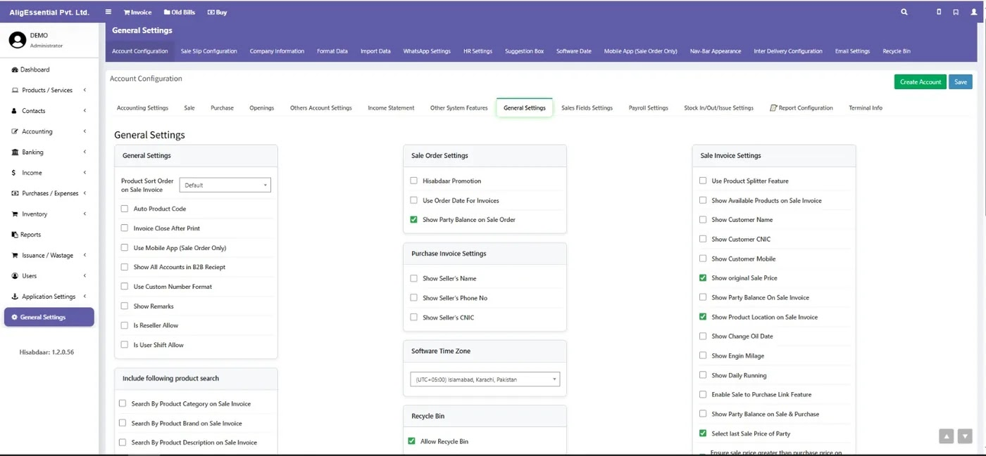

Main Modules
• Business Dashboard
• Products & Services
• Customer & Contact Management
• Sales & Invoice Management
• Purchases & Expenses
• Accounting & Banking
• Inventory & Warehouse Management
• Financial & Sales Reports
• User Management
• Application & General Settings

Sales & Invoice Management
The sales module supports complete invoice processing, including:
• Customer and walk in customer selection
• Product code and product selection
• Quantity and pricing
• Discounts and taxes
• Additional charges
• Payment processing
• Customer balance and invoice history
• Return invoices
• Draft and parked transactions
Sales Flow:
Customer → Products → Pricing → Discounts / Taxes → Invoice Total → Payment

Accounting & Reporting
The system includes a wide range of financial reports such as:
• Trial Balance
• Income Statement
• General Ledger
• Customer & Vendor Ledger
• Cash Flow Statement
• Balance Sheet
• Accounts Receivable & Payable
• Cash Book
• Expense Analysis
• Profit & Loss

Inventory Management
Inventory operations include:
• Product stock tracking
• Product Ledger
• Stock movement
• Purchase & Purchase Returns
• Goods Receive Notes
• Stock Transfers
• Warehouse Wise Stock
• Stock Issues
• Stock Waste
• COGS Ledger
• Dead Stock Analysis

Sales Analytics
Management can monitor:
• Recent sales trends
• Top selling products
• Product wise sales
• Category wise sales
• Monthly sales analysis
• Product profitability
• Sales targets
• Customer performance
• Salesman performance
• Reseller performance

System Configuration
The platform provides extensive configuration options for:
• Accounting and sales settings
• Invoice customization
• Product search
• Purchase invoices
• Sale orders
• Company information
• Email and WhatsApp settings
• User permissions
• Time zone
• Recycle Bin
• Report configuration

Technology & Expertise
Business Management Systems | ERP Applications | Accounting Systems | Inventory Management | Sales & Invoice Workflows | Financial Reporting | Admin Dashboards | Enterprise Applications

Result
Hisabdaar brings sales, inventory, accounting, purchasing, customers, payments, and reporting into one integrated system, giving businesses better operational control, centralized records, and clear visibility into their financial and sales performance.

